­­­­Weekly report

* Week 1 (5-09-2020) --> S.R.S prepared.
* Week 2(12-09-2020) --> Logo designed
* Week 3 (19-09-2020) --> Splash Screen
* Week 4 (26-09-2020) --> Sessional break
* Week 5(3-10-2020) --> Welcome screen
* Week 6(10-10-2020) --> Login page
* Week 7(17-10-2020) --> Registration page
* Week 8(24-10-2020) --> Home page
* Week 9(31-10-2020) --> Database connection
* Week 10(7-11-2020) --> Request Blood
* Week 11(14-11-2020) --> Search Donors & database
* Week 12(21-11-2020) --> Call and share functions

**Screen shots : -**

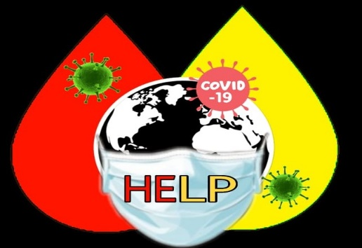 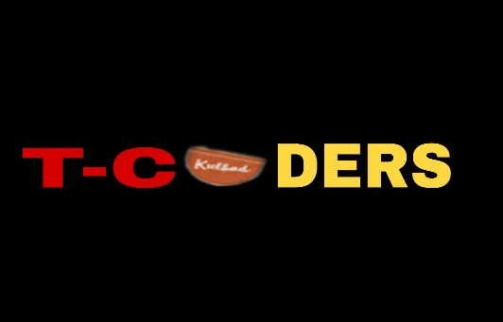

(Logo) (T-coders logo)

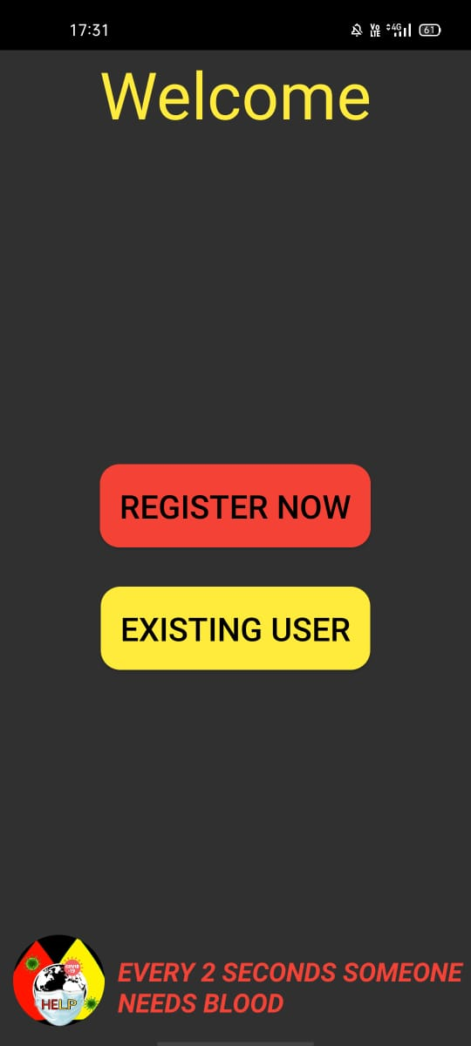 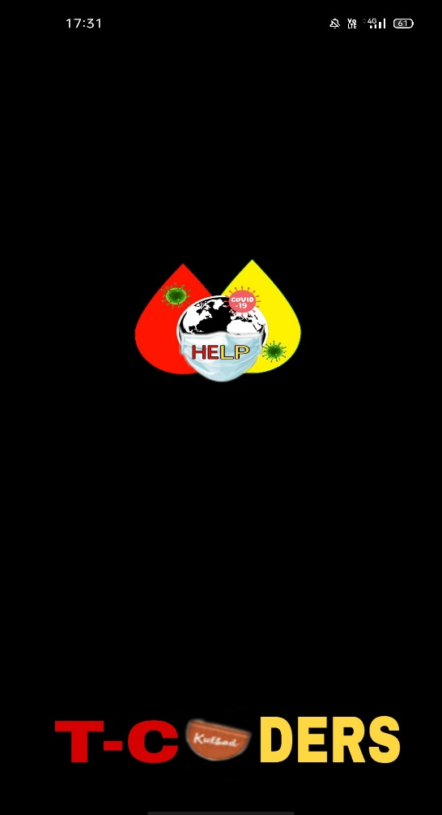

(Welcome Screen) (Splash Screen)

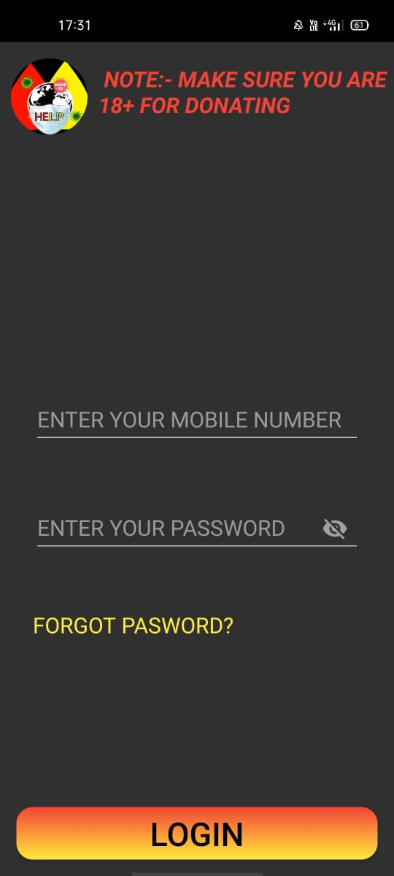 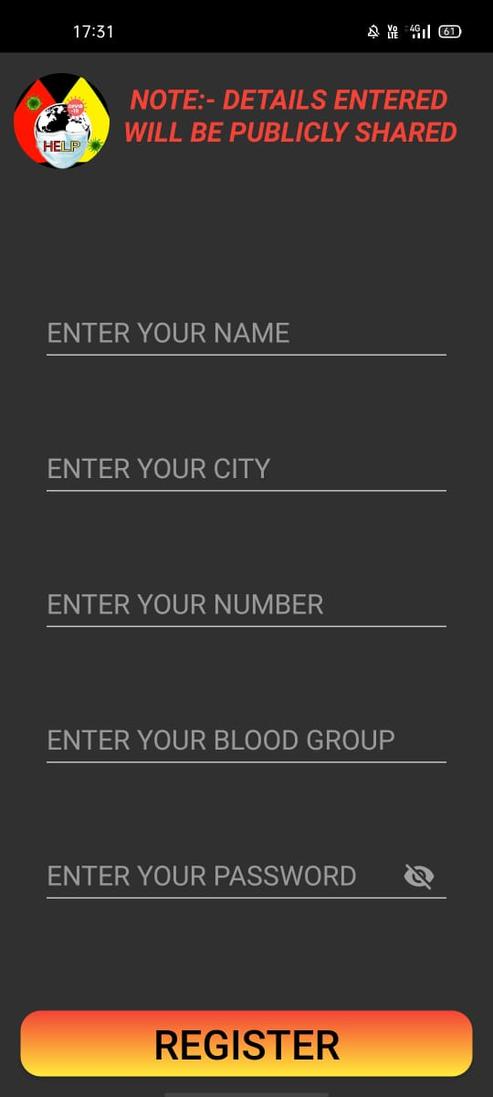

(Login) (Register)

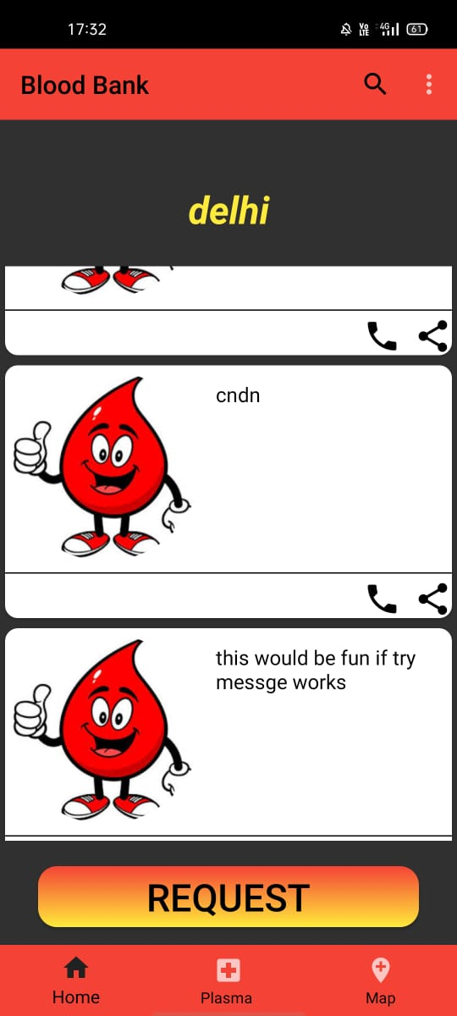 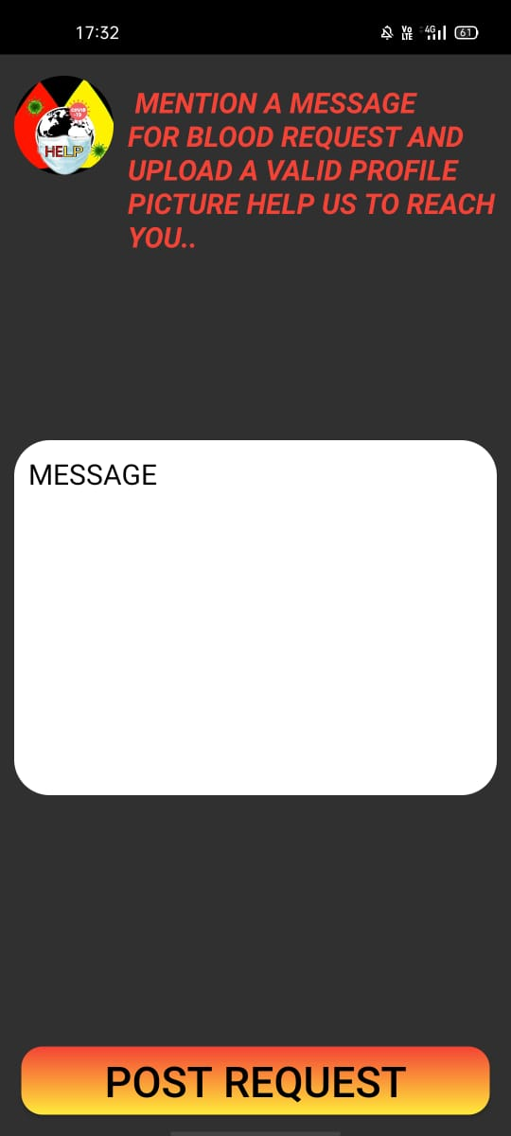

(Home Page) (Request Page)

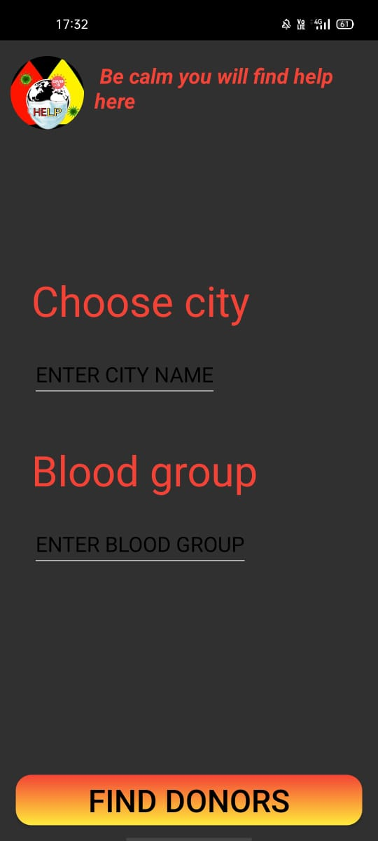 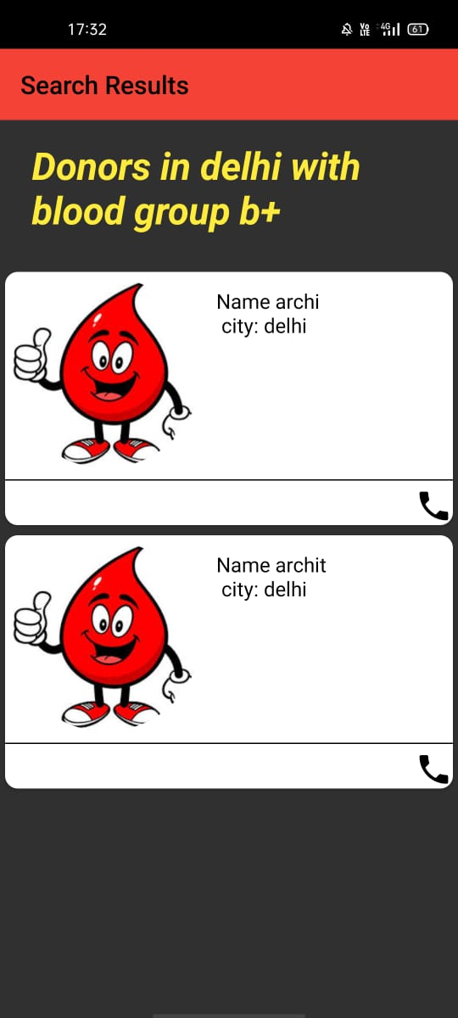

(Find Donors) (Search Donors)

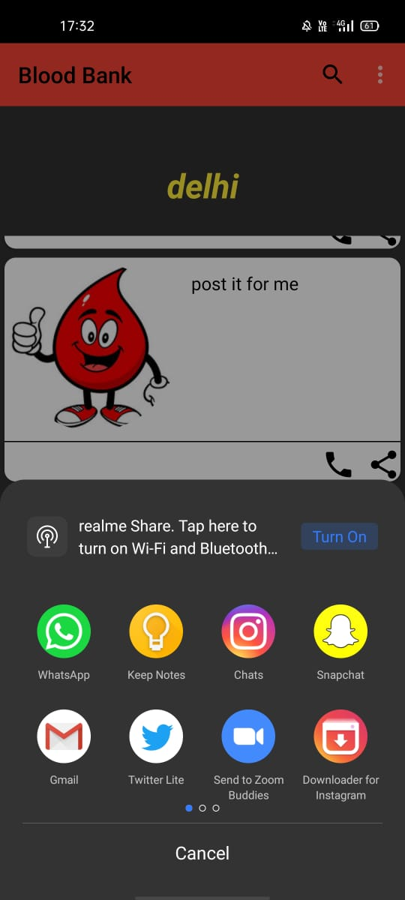 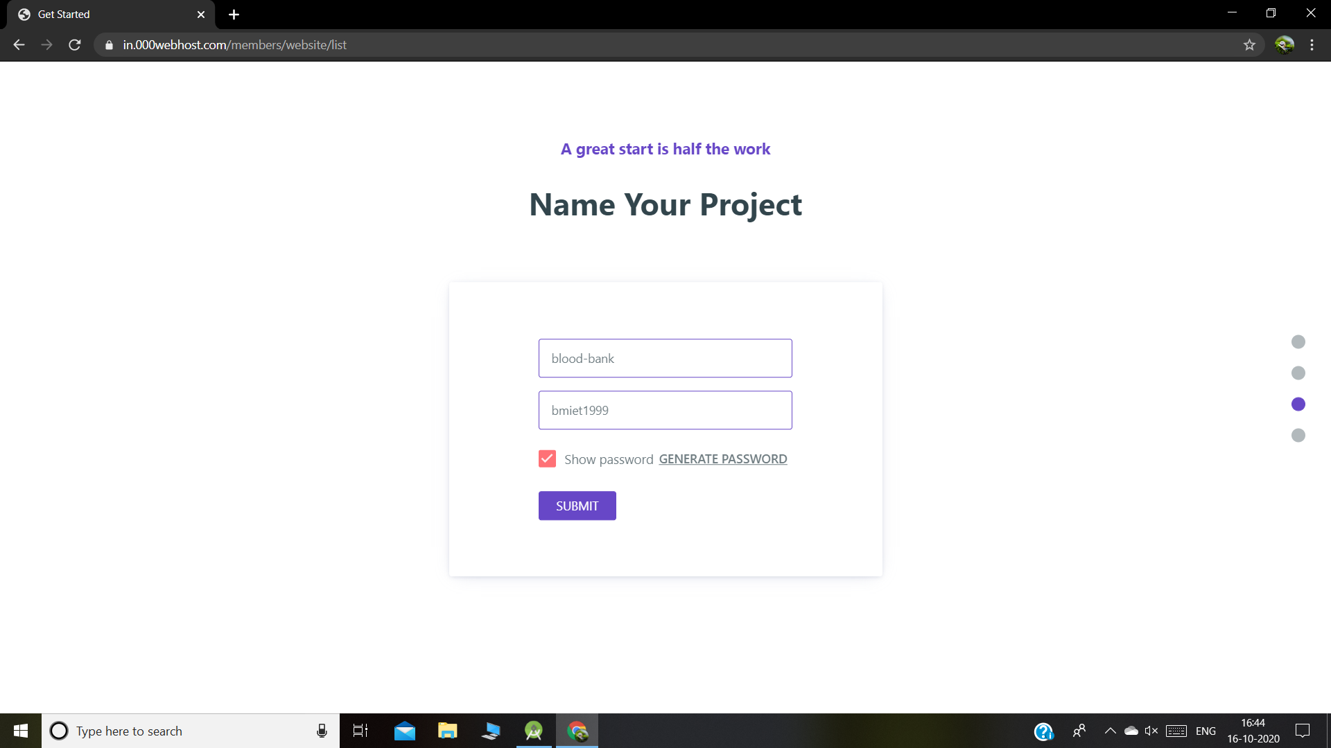

(Share Request) (000WebHost)